Depending on the usage, the UC machines can be customized into four different basic versions: glass washer, dish washer, bistro and cutlery washer. The single button operation is colour coded and has an integrated status indication. A progress indication is also integrated into the display. The smart Winterhalter touch-display offers three washing programmes (cutlery washer only one programme), accompanied by self-explanatory, language neutral symbols. This guarantees intuitive, error-free operation and the programmes allow a customer specific programming. Furthermore a lot of special programmes such as intensive, energy-saving, low-noise or short are available within all models. A large number of technical innovations have enabled Winterhalter to achieve dishwashing results of a quality never seen before. Moreover the machine works in the most economical way.

Features:
- Innovative, full-coloured touch-display with robust glass surface
- WLAN-function integrated
- USB-interface for software updates
- VarioPower warewashing system: S-shaped wash field with maximum surface coverage and optimized jet geometry for highest cleaning power and adjustable water pressure
- Removable, quick release wash fields
- Tank water exchange programme
- Descaling programme
- Integrated rinse aid and detergent dosing device
- Integrated storage tanks for rinse aid and detergent
- Quadruple filtration system with clouding sensor
- Deep-drawn tank with hygienic tank heater
- Deep-drawn rack guide
- Guided self-cleaning programme
- Thermostopp for hygienic safety
- Hygiene logbook with data memory of all hygiene relevant data
- Non-pressurised boiler
- Drain pump
- Closed plastic rear cover (spray guard IPX3)
- 1 rack package according to choice
- Multiphasing (all machines can be used as 3-phase AC or 1-phase AC machines)
- Main power cable according to choice
- Inlet water and drain hose
- Double-skinned housing and door
- Door safety switch and vent position
- Detailed error display with error code and text
- Video-enhanced recommendations
- Time-controlled automatic start-up and shut-down
- PIN-protected chef and service technician level
- Temperature display (tank and boiler)
- Display of operating data
- Contact data for service technician and chemical suppliers stored
- Data logger
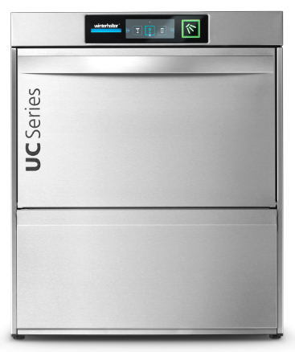
- Soft start of the wash pump
- Under counter or stand mounted

Your benefits are:
- Best wash results
- Low operating costs
- Easy operation
- Energy efficiency
- Short wash cycles
- High service friendliness

Options:
- CONNECTED WASH (free App) – connected warewasher for monitoring operating data*
- Circulating air heat recovery system Energy (85 mm higher, saves up to 0.1 kWh per cycle)**
- Cool model (cold rinse water for cool glasses)
- Suction tubes with level control
- Integrated softener (up to 31 °gTH)
- Variety of rack packages and plinths
- Double-rack system
- Excellence-i, built in reverse osmosis (up to 35 °gTH)
- Excellence-iPlus, built in reverse osmosis equipped with upstream integrated water softener (up to 31 °gTH)
- Data interface according DIN 18875 (for connection of energy management systems)***
- Stainless steel rear cover
- PAY PER WASH – fixed price per wash cycle*
- LAN-function (available as kit)

* Not available in all markets
** Only cold water
*** CAUTION: Connecting the warewasher to an external energy management (EMS) system has an influence on programme cycle times and
temperatures. The operator must therefore ensure rated temperatures are adhered to.

UC-M  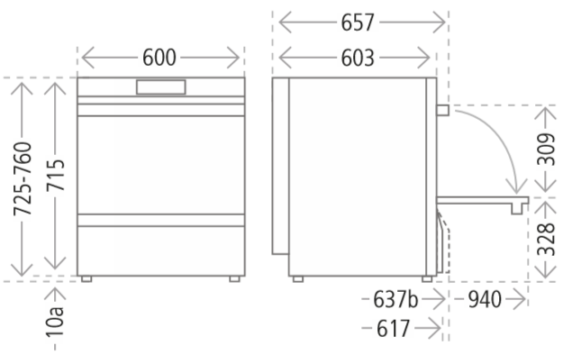  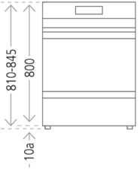  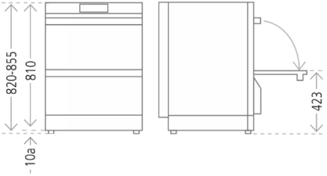  UC-M Excellence-i / iPlus UC-M Energy  Max. theoretical capacity  Glass washer: 77 / 48 / 32 / 22 (racks / h)  Dishwasher: 66 / 40 / 28 / 24 (racks / h)  Bistro dishwasher: 66 / 40 / 32 / 28 (racks / h)  Cutlery dishwasher: 21 / 11 (racks / h)  Rinse water consumption^{*3} (depends on programme)  Glass-, dish- and bistro  Dishwasher: from 2.0 l per rack  Cutlery dishwasher: from 3.1 l per rack  Thermal radiation (depends on programme and version)  Sensitive / latent (1~): 0.3 / 0.1 kW  Sensitive / latent Energy (1~): 0.2 / 0.1*¹ kW  Sensitive / latent (3~): 0.6 / 0.2 kW  Sensitive / latent Energy (3~): 0.5 / 0.2*¹ kW  Extraction  Cubic metres / h (glasses/bistro): 6.1  Cubic metres / h (dishes): 5.3  Cubic metres / h (cutlery) 1.3  Relative humidity: 100 %  Rel. humidity Energy: 75 %*¹  Temperature: 60 °C  Temperature (cutlery): 69 °C  Temperature Energy: 35 °C*¹ | Dimensions  Width x depth: 600 x 603 mm  Height: 725 – 760 mm  Height with heat recovery: 810 – 845 mm*¹  Height Excellence-i / -iPlus: 820 – 855 mm*²  Depth with door open: 940 mm  Rack dimensions: 500 x 500 mm  Clear entry height: 309 mm  Water connection: G ¾”  Waste water hose (Outer diamter): ø 24/28/46 mm  (staged connection)  General data  Weight Standard (net / gross): 64 / 74 kg  Weight Energy (net / gross): 70 / 80 kg*¹  Weight Excellence-i / iPlus  (net / gross): 85 / 95 kg*²  Tank capacity: 15.3 l  Circulating pump  (Depends on selected progr.): 150 - 200 l/min  Noise emission  (Depends on selected progr.): max. 55 dB(A)  Impact resistance display: IK07  Splash guard: IPX3 (plastic rear cover)  IPX5 (stainless steel r.c.)  Cycle duration  Glass washer: 47 – 163 sec.  Dishwasher: 54 – 150 sec.  Bistro dishwasher: 54 – 128 sec.  Cutlery dishwasher: 171 – 327 sec.  Water connection  Flow pressure: 1.0 – 6.0 bar  Flow pressure Energy: 1.5 – 6.0 bar*¹  Flow pressure  Excellence-i / -iPlus: 1.4 – 6.0 bar*²  Flow rate: at least 4 l/min.  Flow rate Energy: at least 3 l/min.*¹  Water inlet temp.: max. 60 °C  Water inlet temp. Energy & Cool: max. 20 °C*¹  Water inlet temp.  Excellence-i / -iPlus: max. 35 °C*²  Certificates  CB, SVGW, WRAS  Weight pressure point per foot  Standard / Energy: max. 24.5 / max. 26.5 kg*¹  Excellence-i / -iPlus: max. 29.5 kg*²

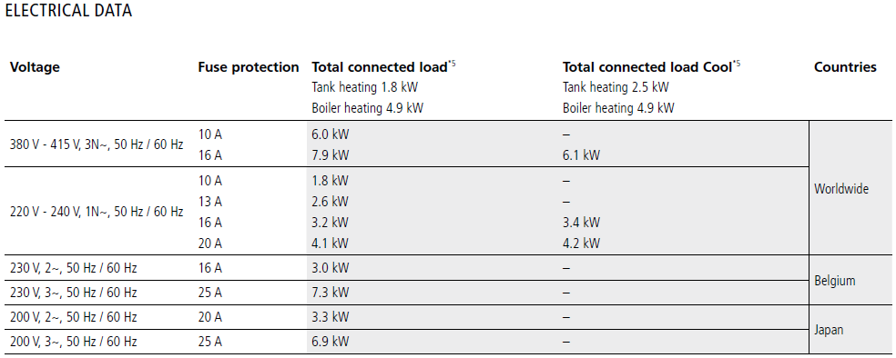
*4
*4 / *5

*¹ Only with Energy version
*² Only with Excellence-i / iPlus
*³ Under ideal conditions. The fresh water consumption depends on the on-site conditions. The precise adjustment takes place during
commissioning.
*⁴ The actual connected load varies depending on the mains voltage.
*⁵ + 0.2 kW with Excellence-i and Excellence-iPlus

